

ASSIGNMENT

LEVEL 5

COMP50001 : Commercial Computing

COM24A1_CYS24A1
Hand Out Date: Jan 2026

Hand in Date:
Individual Assessment 1– 23rd Jan 2026
Individual Assessment 2– 24th week
Group Assessment Component 1 – 12th week
Group Assessment Component 2 – 24th week

Ganidu Udage – CB014572

INSTRUCTION TO CANDIDATES

- Late submission will be awarded zero (0) unless extenuating circumstances (EC) are upheld.

- Cases of plagiarism will be penalized.

- The assignment should be submitted as softcopy via LMS

- All evidences related to the sprint implementation in group assignment must be show cased in the final documentation.

Contents

1. Introduction 2
2. Skill Matrix (STARR Technique) 3
3. Career Goals and Action Plan 8
2.1 Short-Term Goals 8
2.2 Medium-Term Goals 8
2.3 Long-Term Goals 8
2.4 Skill Requirements 9
4. Skills Audit & Reflection 10
4.1 Reflection 10
5. Personal SWOT Analysis 13
6. Action Plan 14
7. My CV 15
8. LinkedIn Profile & Online Presence 17
9. References 18
10. Appendices 19
Appendix 1 – Job Descriptions (Short Term Goal) 19
Appendix 2 – Job Description (Medium Term Goal) 23
Appendix 3 – Job Description (Long Term Goal) 25

Figures

Figure 1 Short Terms Goal Job 1 19
Figure 2 Short Terms Goal Job 2 19
Figure 3 Short Terms Goal Job 3 20
Figure 4 Short Terms Goal Job 4 20
Figure 5 Short Terms Goal Job5 21
Figure 6 Short Terms Goal Job 6 21
Figure 7 Short Terms Goal Job 7 22
Figure 8 Medium Terms Goal Job 1 23
Figure 9 Medium Terms Goal Job 2 23
Figure 10 Medium Terms Goal Job 3 24
Figure 11 Medium Terms Goal Job 4 24
Figure 12 Long Terms Goal Job 1 25
Figure 13 Long Terms Goal Job 2 25

Tables

Table 1 Showing skill requirements linked to job descriptions 9
Table 2 Skills audit referring to skill requirements for job description 10
Table 3 Showing strength, weaknesses, opportunities, threats 13
Table 4 Action plan describing steps required to succeed with career plan 14

Introduction

I am Ganidu Sasmitha Rajapaksha Udage, currently pursuing a BSc (Hons) Computer Science degree at the Asia Pacific Institute of Information Technology (APIIT). As a dedicated undergraduate with a focused ambition to become a Cloud Security Engineer, my professional identity is built upon a strong foundation of discipline and leadership established during at Royal College, Colombo. Through my roles as Senior Steward and the Chief Organizer of the Buddhist Brotherhood, I built-up the resilience and teamwork that are very important for the cybersecurity area. Along with these, my victory in the All-Island Baseball tournaments has been one of my lifetime experiences defining my battle for upholding the standards even in the most hectic technical environments.

Purpose of this Portfolio
This Individual Assessment is a reflection of my transition into the professional world, so it represents a roadmap. It identifies my "current Skill Matrix" using the STARR technique, offers an honest Personal SWOT analysis, and lays out a detailed Action Plan including the mandatory completion of the LinkedIn Learning " Cloud Security" path to ensure I am prepared for the high global demand in cloud security.

Skill Matrix (STARR Technique)

Q1: Communication
- Situation: While we were presenting our project "Disaster Response Offline Reporting System" at the 2025 APIIT Hackathon to the judges, I was overwhelmed by the thought of all the other universities that were participating and the intense competition that I felt a strong panic and pressure.
- Task: My role was to explain to the judges, who were not all technically trained, the technical logic behind our project and how the offline synchronization worked in our system.
- Action: To control my panic and not get overwhelmed by the crowd, I resorted to simplification.
- Result: The judges understood our concept, and we were received a participation certificate for our effort.
- Reflect: I learned from this how to control my panic like this situation.
Q2: Leadership & Initiative
- Situation: I, as the Chief Organizer of the Royal College Buddhist Brotherhood, organized the society to maintain a higher standard for Clubs Felicitation.
- Task: I have to do lot of work because I’m the chief organizer, so I have to organize every event and I’m so busy because of that.
- Action: I actively managed the team's efforts and oversaw the organization of key society projects.
- Result: Our society was awarded an "A" Grade and won the "Best Publicity Award".
- Reflect: My first leadership experiences have taught me how to lead teams of varying compositions to get outstanding performance
Q3: Positive Team Contribution
- Situation: In December 2025, I took part in a Capture the Flag competition, the theme of which included forensics and steganography. Its difficult to do because I’m not a cyber student and I tried to capture the flag but it’s not worked.
- Task: The task assigned to me is to help the team in solving puzzles involving hidden data in pictures.
- Action: I was able to share with the class my method of solving it, which helped us record the flags we identified. I didn’t panic done my work.
- Result: We were able to solve more puzzles and increase the overall score of the team.
- Reflect: it is important to work together in the area of cybersecurity, sharing knowledge helps the entire team progress faster.
Q4: Managing Several Tasks
- Situation: Balancing my Senior Steward duties at Royal College with A/L Physical Science studies.
- Task: I had to maintain school discipline while simultaneously preparing for difficult exams in Physics and Chemistry.
- Action: I developed a strict daily schedule to allocate specific time for school board meetings and night-time study sessions.
- Result: I successfully completed both stewardship tenures and qualified for my degree at APIIT.
- Reflect: Efficient scheduling is the only way to succeed when managing multiple high-pressure responsibilities.
Q5: Difficult Decisions
- Situation: Choosing between pursuing a general software role or specializing in the competitive Cloud Security field. Because it’s deciding my future.
- Task: I had to decide where to invest my time for professional certifications, specifically between AWS and general web development.
- Action: I analyzed the "high global demand" for cloud security and decided to focus on the AWS Security Specialty.
- Result: I now have a clear career roadmap that aligns with local companies like IFS and Dialog Axiata.
- Reflect: Researching industry trends is vital when making long-term career decisions to ensure job security.

Employability skills

Story 1 – APIIT Hackathon
Story 2 – Deciding My Future Studies
Story 3 – Leading a School Society
Story 4 – Cybersecurity Team Contribution
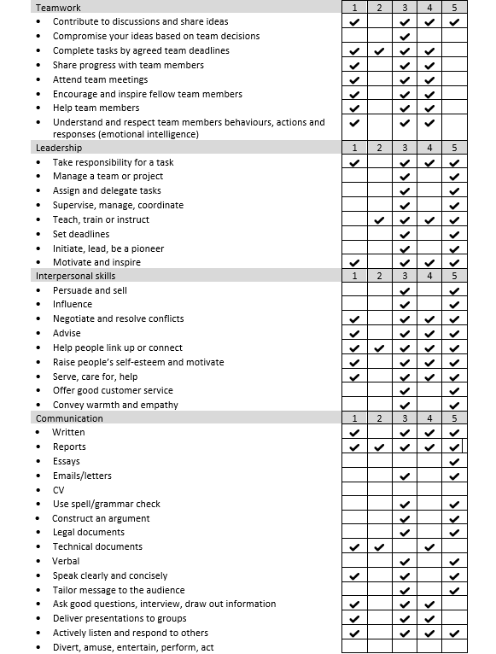
Story 5 – Balancing Leadership & Studies

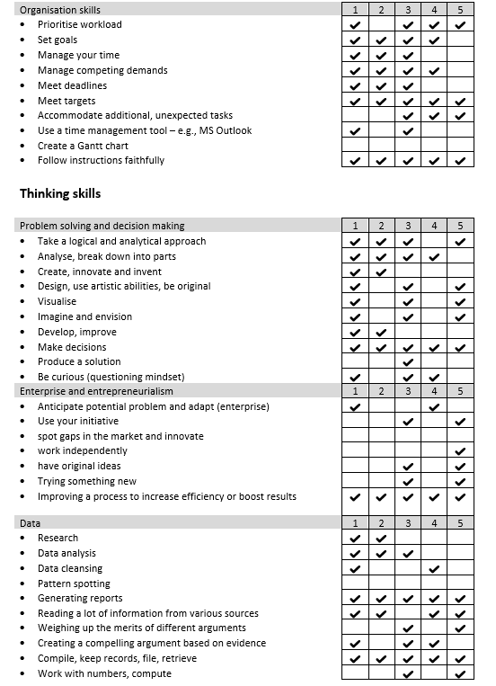

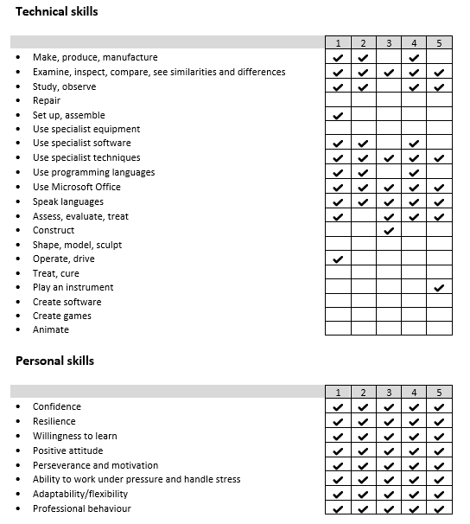

Career Goals and Action Plan

My career objective is to transition from a technical undergraduate to a Cloud Security Engineer, eventually moving into a DevSecOps or Cloud Security Management role within leading technology firms like IFS or Dialog Axiata.

2.1 Short-Term Goals

- Complete the "Become a Cybersecurity Professional" learning path on LinkedIn to bridge the technical gap between academic theory and industry practice.
- Earn the AWS Certified Cloud Practitioner certification to formalize the cloud computing skills currently showcased on my LinkedIn profile.
- Maintain high grades in Level 5 modules at APIIT, specifically focusing on Commercial Computing and Database Systems.
- Graduate with a BSc (Hons) Computer Science from APIIT/University of Staffordshire.

2.2 Medium-Term Goals

- Secure an Associate Cloud Security Engineer or position at a reputable local firm like Sysco Labs, Dialog and SLT Mobitel.
- Obtain the AWS Certified Security Specialty to demonstrate expert-level ability in securing cloud workloads.
- I aim to start my masters in this period.

Long-Term Goals

- Advance into a DevSecOps Engineer role, integrating security into the continuous integration/continuous deployment (CI/CD) pipeline.
- Transition into a Cloud Security Director.

2.4 Skill Requirements

Table 1 Showing skill requirements linked to job descriptions

Category | Skill | Link
Academic | BSc (Hons) Computer Science | Appendix1, Appendix2
 | Computing Foundation | Appendix1
 | Database Systems & SQL | Appendix2
Technical | Cloud Cybersecurity | Appendix2, Appendix3
 | Network Security | Appendix2
 | Programming (Python/C#) | Appendix1, Appendix2
 | Web Development (HTML/CSS/JS) | Appendix1
 | Cloud Technologies | Appendix1, Appendix3
Professional | Agile Project Management | Appendix1
 | Problem Solving | Appendix1

Skills Audit & Reflection

Table 2 Skills audit referring to skill requirements for job description

Category | Skill | Skill Level (0 - 5)
Academic | BSc (Hons) Computer Science | 4
 | Computer Foundations | 5
 | Database Systems & SQL | 4
Technical | Cloud Cybersecurity | 4
 | Network Security | 4
 | Programming (Python, C#) | 3
 | Web Development (HTML/CSS/JS) | 4
 | SQL & Database Management | 4
Professional | Leadership & Teamwork | 5
 | Time Management | 4
 | Risk Management | 4

4.1 Reflection
BSc (Hons) Computer Science
I have a solid theoretical understanding of computer science that I developed during my degree. I ranked myself 4 because I do not only focus on writing code, I also look at the logic behind it and the design patterns. I have a good command of the discipline but I am aware that one can always go deeper and specialize in a technical order to achieve an expert level.
Computer Foundations
My knowledge of computer foundations is the main one that supports my technical troubleshooting skills. I familiar with OS architecture, memory management and hardware interactions. This basic knowledge enables me to trace system issues at a deeper level than those who stay at the high, level programming only, this level of understanding is key for stable commercial systems.

Database Systems & SQL
I have an excellent understanding of relational logic and data integrity. I am able to do more than just simple querying; I can design complex database schemas completely from scratch. Being able to translate theoretical data modeling into practical engineering is an important skill that I can use to handle huge amount of data in a commercial setting.
Cloud Cybersecurity
It has been my major task to secure cloud, native environments as I am conscious of the fact that modern businesses are moving towards a "cloud, first" strategy. I am capable of handling Identity and Access Management (IAM), encryption protocols, as well as secure cloud infrastructure setups. I realize that nowadays protecting cloud assets is the number one priority of any business.
Network Security
The knowledge that I have in the field of network security is a great addition to the cloud skills that I have. I have been involved in projects where firewalls were used, VPNs were set up, and packet analysis was done. By knowing how to secure data when it is being transferred or when it is stored, it is possible to have a proper security stance of an organization's digital infrastructure.
Programming, Python, C#, JS
Thanks to my ability to work with a number of programming languages, I am able to create applications and scripts that are functional. Although I can already develop software and solve problems effectively, I am taking steps to learn more about design patterns and techniques of optimization which will help me move from a functional level to a more advanced architectural level.

Web Development, HTML/CSS
My expertise in the front, end development field is such that I am able to design user interfaces that are both easy, to, use and responsive. This kind of skill is very important in the commercial world as it helps ensure that business tools are not only accessible but also giving a professional user experience.
SQL & Database Management
Due to my academic background, I am also able to undertake database management practically. When it comes to the administration of databases, I am capable of not only carrying out tasks that are at a higher level but also of query optimization thus ensuring that data, driven commercial applications are trading off performance and reliability.
Leadership & Teamwork
I work well with others as I am very open and understanding to the importance of synergy in a technical environment. I can facilitate meetings, assign tasks properly and also be able to give timely help to my peers to ensure that our work and efforts are not reduced to eliminate the value of the work.
Time Management
I have a firm and good method in getting my works done and I am always on time with the deadlines. In a commercial computing world where everything is time, bound, my skill of ordering my works and time management is what really makes the main projects deliverables to be on the schedule.
Risk Management
I have a clear and business, oriented understanding of technical problems. My risk assessment skills, be it on security vulnerabilities or being able to identify project bottlenecks, help me to come up with ideas on how to protect the company's interests and also keep operations running smoothly.

Personal SWOT Analysis

Table 3 Showing strength, weaknesses, opportunities, threats

Strengths | Weaknesses
Hands-on CTF experience (forensics, steganography). | Limited professional exposure to enterprise cloud environments.
Technical proficiency in SQL and Web Development. | Balancing university, personal business, and certification study.
High Discipline: Background in competitive sports (Baseball), Clubs and society and Cub Scout. | Academic Recovery: Overcoming challenges in Combined Mathematics during A/Ls.
Opportunities | Threats
High global and local demand (IFS, Dialog) for cloud security. | Rapidly evolving cyber threat landscape (ex- AI-powered attacks).
Remote work opportunities for international firms. | High competition for entry level in the local market.

Action Plan

Table 4 Action plan describing steps required to succeed with career plan

Goal | Action Required | Success criteria | By When | By who
Complete university course | Attend all lectures on time, maintain 70%+ attendance, and engage deeply in modules. | Achieve a Grade of 2.1 or higher in the overall BSc (Hons) Computer Science course. | 2026 | Myself
Improve knowledge in AWS | Search about AWS watch videos and Complete courses in AWS. Practice AWS by doing practices. | I can improve my knowledge to work with industry with more experience. | March 2026 | Myself
Get industry experience | Searching for job opportunities apply for internship. | I can get experience entry level to my future goals. | June  2026 | Myself
Completing  LinkedIn certificates | Follow the courses in LinkedIn Learning.  Allocate 1 hour for 6 days to complete the course. | Gain the AWS Security Specialty Certification and demonstrate automated security scripts. | December 2026 | Myself
Professional experience | Apply for associate or intern security roles at firms like IFS Sri Lanka or Dialog Axiata. | Secure a formal placement or Associate Cloud Security Engineer position. | 2027 | Myself
Career progression | Gain certificates, cloud security projects and leadership skills from Royal College to move into DevSecOps or Management. | Transition into a Cloud Security Manager or Director role. | 5+ Years | Myself

My CV
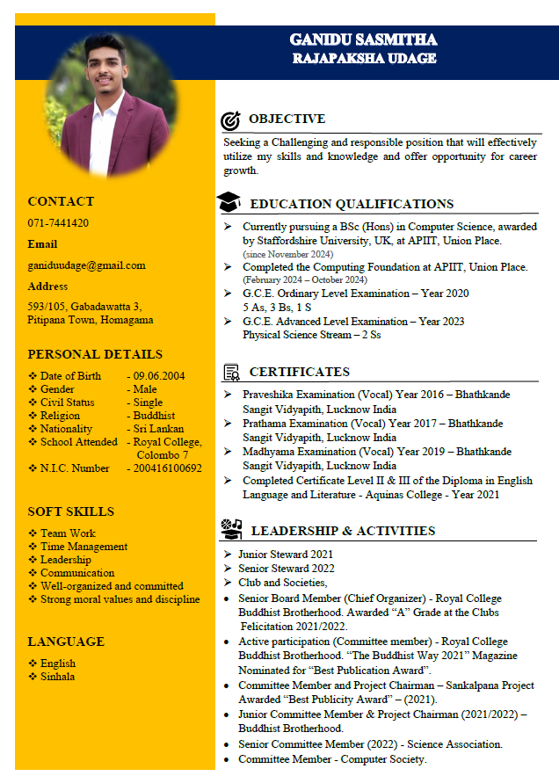

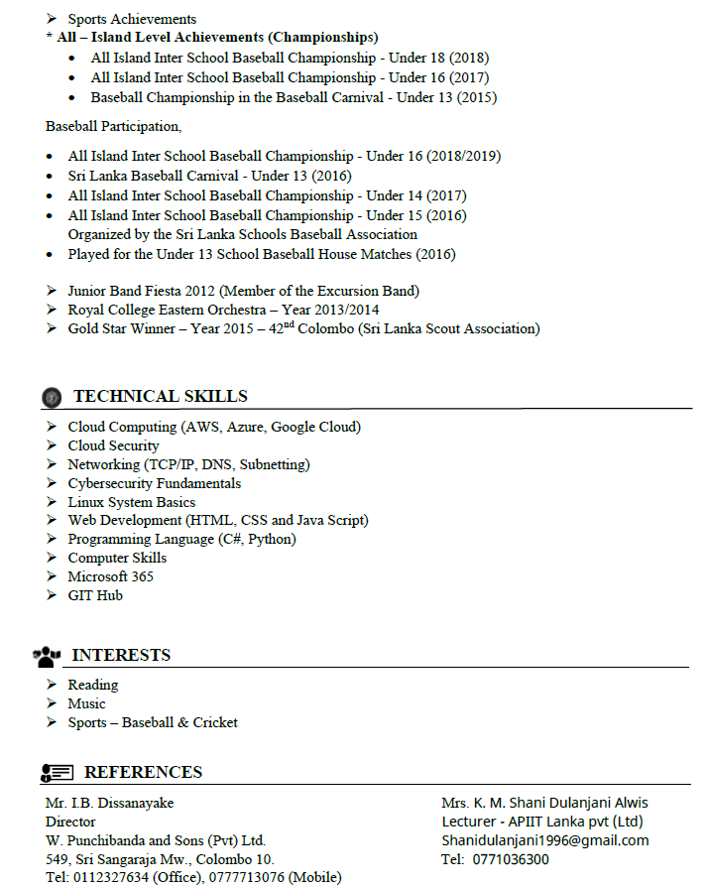

LinkedIn Profile & Online Presence

Current Online Presence and Skill Showcasing

My LinkedIn profile acts as a complete digital portfolio and provides authentication of my expert scientific trail. The profile is designed in such a way that it not only highlights my academic credentials at APIIT but also the self-driven technical certifications that I have obtained.

Key Skills & Evidence now on my profile:

- Cloud Security Specialization: I have completed a rigorous series of professional courses including Introduction to Security Principles in Cloud Computing, Strategies for Cloud Security Risk Management, and Google Cloud Cybersecurity. This guarantees my readiness for the high-demand cloud roles.

- Networking & Infrastructure: My profile suggests basic understanding of Cisco Networking (Switching and Routing) and Network Security Operations through certified LinkedIn Learning paths.

- Programming Proficiency: I have listed the skills in Python, C#, JavaScript, HTML and CSS and that gives the impression of a diversified technical toolkit for securing scripts and web development.

- Modern AI & Data Skills: I have kept myself updated with the latest industry trends through my certifications in Prompt Engineering for Generative AI and Database Foundations, with an emphasis on Data Structures and SQL.

- Project Management: To face Commercial Computing project and getting ready for the PMI Agile Certified Practitioner (PMI-ACP) are my means of demonstrating that I can work in well-structured modern development environments.

Learning Path and Growth Strategy

I view LinkedIn as my primary platform for "learning in public." My plan is to bridge the gap between my BSc Computer Science degree and the practical requirements of local companies like IFS Sri Lanka and Dialog Axiata, which is the goal of the company.

My LinkedIn profile link - https://www.linkedin.com/in/ganidu-sasmitha-0b5976392/

References

- Anon., 2026. APIIT. [Online]
Available at: https://www.google.com/aclk?sa=L&pf=1&ai=DChsSEwjCxPLMvqiSAxXMYA8CHXoAFnMYACICCAEQABoCdGI&co=1&ase=2&gclid=Cj0KCQiAm9fLBhCQARIsAJoNOcs4Lx99z72KgyFwPv4yH1U6-ja6ndVVdQ5aj65GYZIMsFsFMFUPq28aAs-GEALw_wcB&cid=CAASuwHkaNGW773VBfA5t1iuRcKNyH2K8KKwI5-GDQXTfm5xR2i
- Anon., 2026. Indeed. [Online]
Available at: https://www.indeed.com/
- Anon., 2026. Linkedin. [Online]
Available at: https://www.linkedin.com/

Appendices

Appendix 1 – Job Descriptions (Short Term Goal)

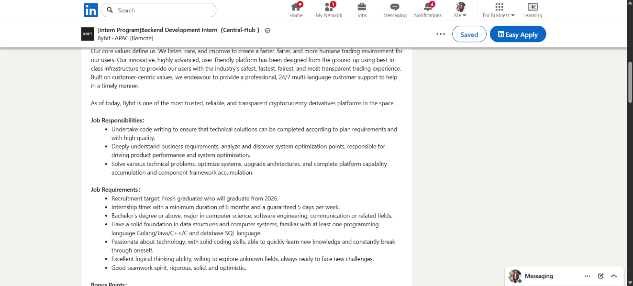
Skill - BSc (Hons) Computer Science
Figure 1 Short Terms Goal Job 1

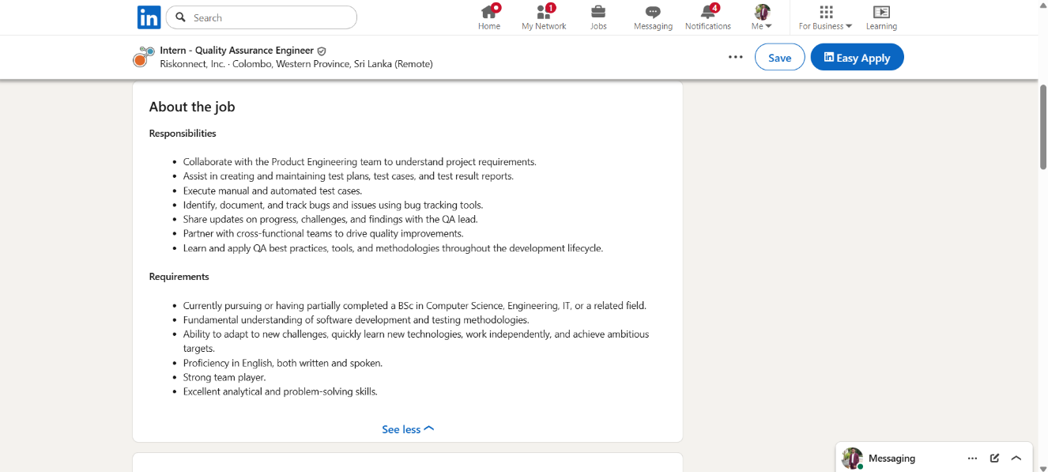
Skill - Computing Foundation
Figure 2 Short Terms Goal Job 2

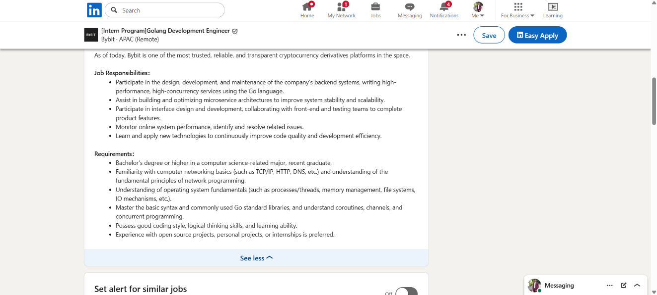
Skill - Programming (Python/C#)
Figure 3 Short Terms Goal Job 3

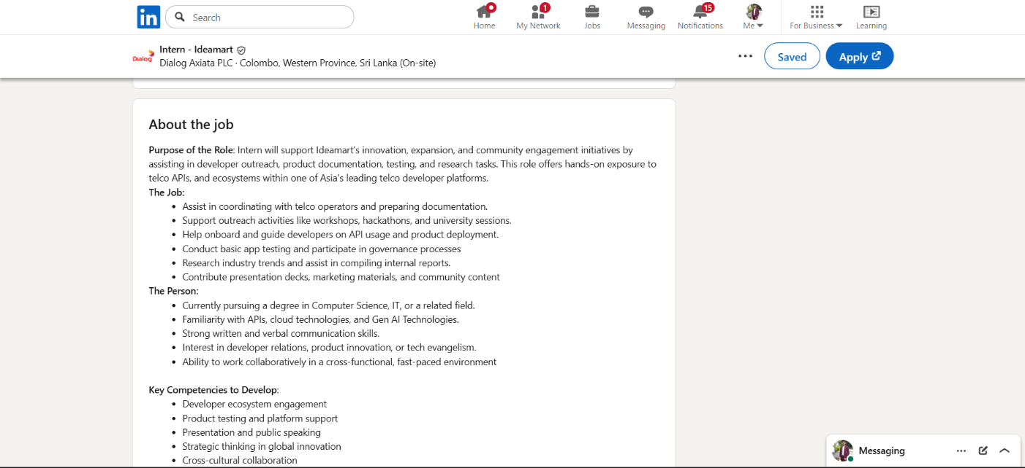
Skill - Cloud Technologies
Figure 4 Short Terms Goal Job 4

Skill - Agile Project Management
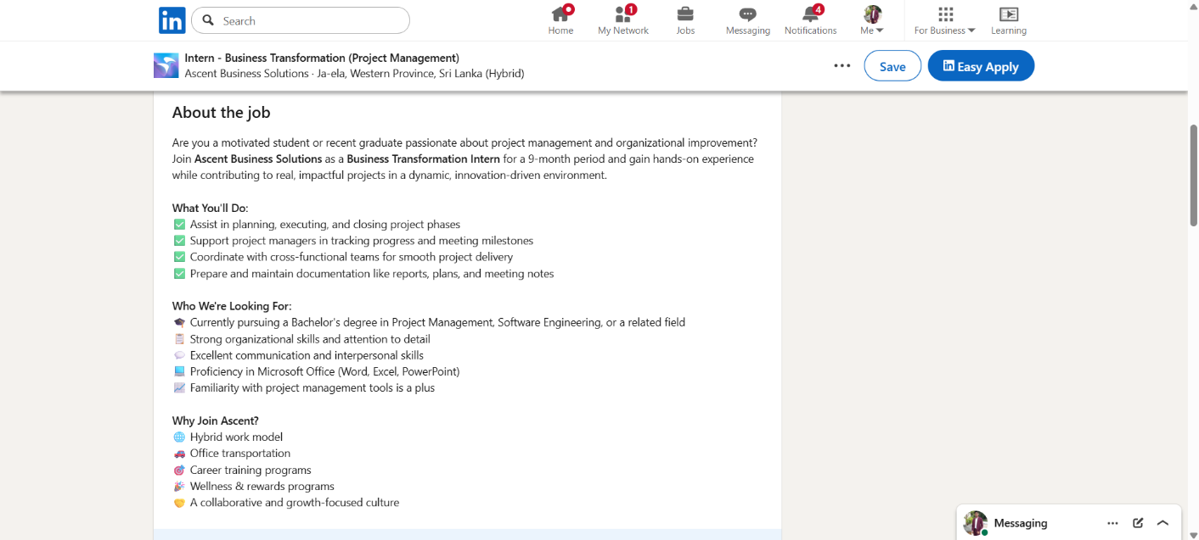
Figure 5 Short Terms Goal Job5

Skill - Problem Solving
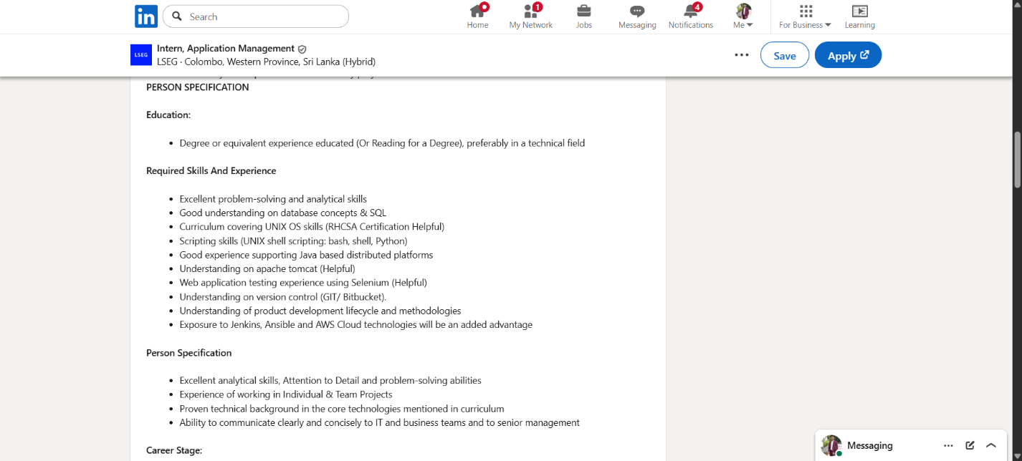
Figure 6 Short Terms Goal Job 6

Skill - Web Development (HTML/CSS/JS)
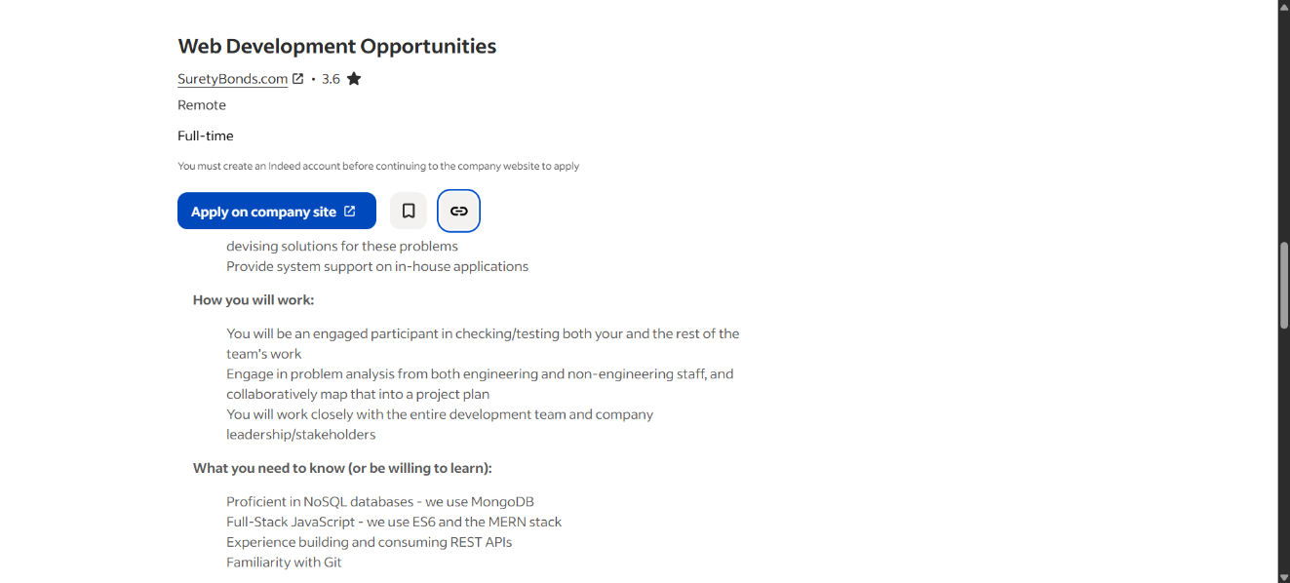
Figure 7 Short Terms Goal Job 7

Appendix 2 – Job Description (Medium Term Goal)

Skill - BSc (Hons) Computer Science
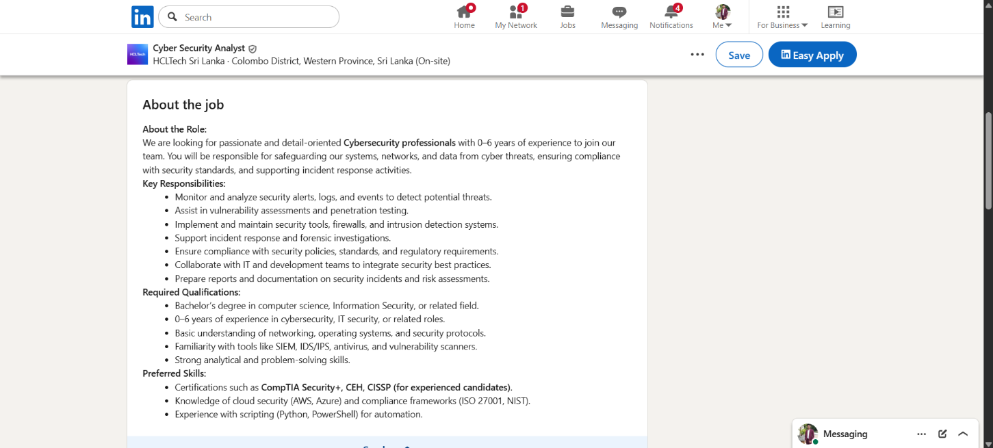
Figure 8 Medium Terms Goal Job 1

Skill - Database Systems & SQL
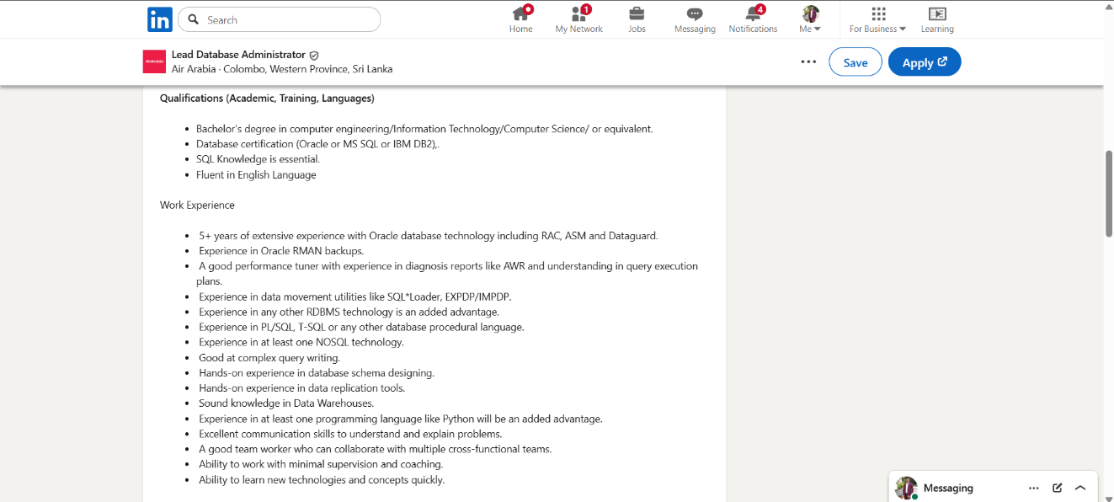
Figure 9 Medium Terms Goal Job 2

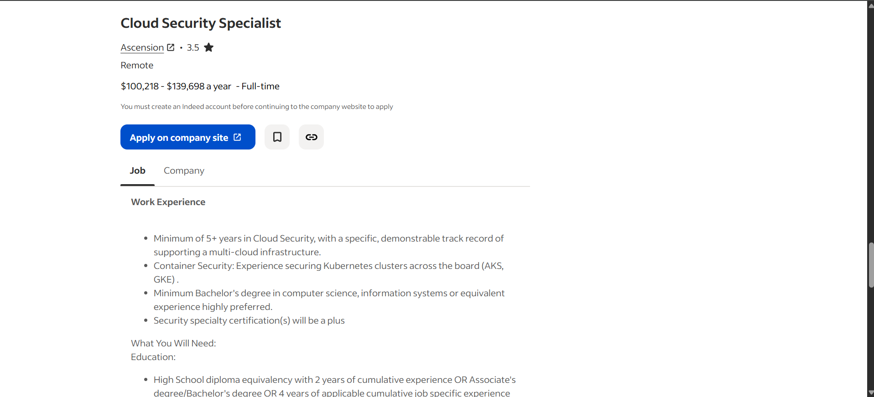
Skill - Cloud Cybersecurity
Figure 10 Medium Terms Goal Job 3

Skill - Programming (Python/C#)

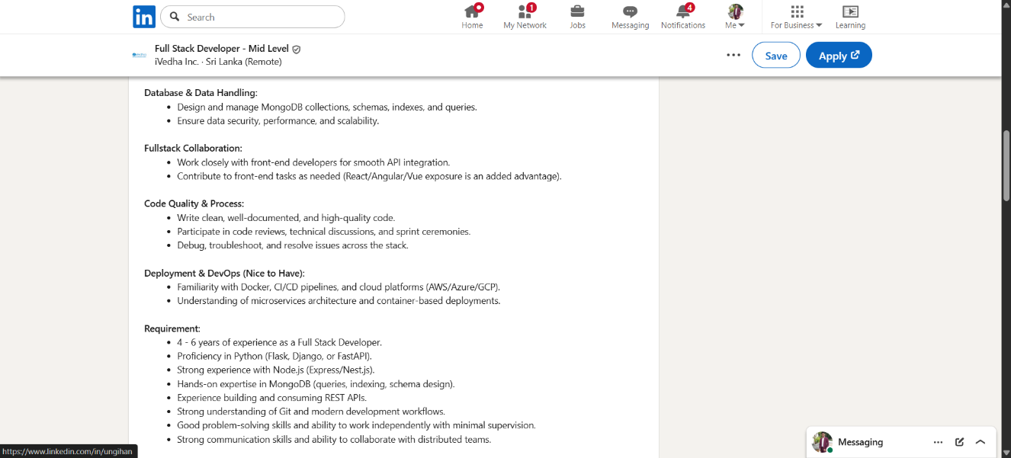
Figure 11 Medium Terms Goal Job 4

Appendix 3 – Job Description (Long Term Goal)

Skill - Cloud Cybersecurity

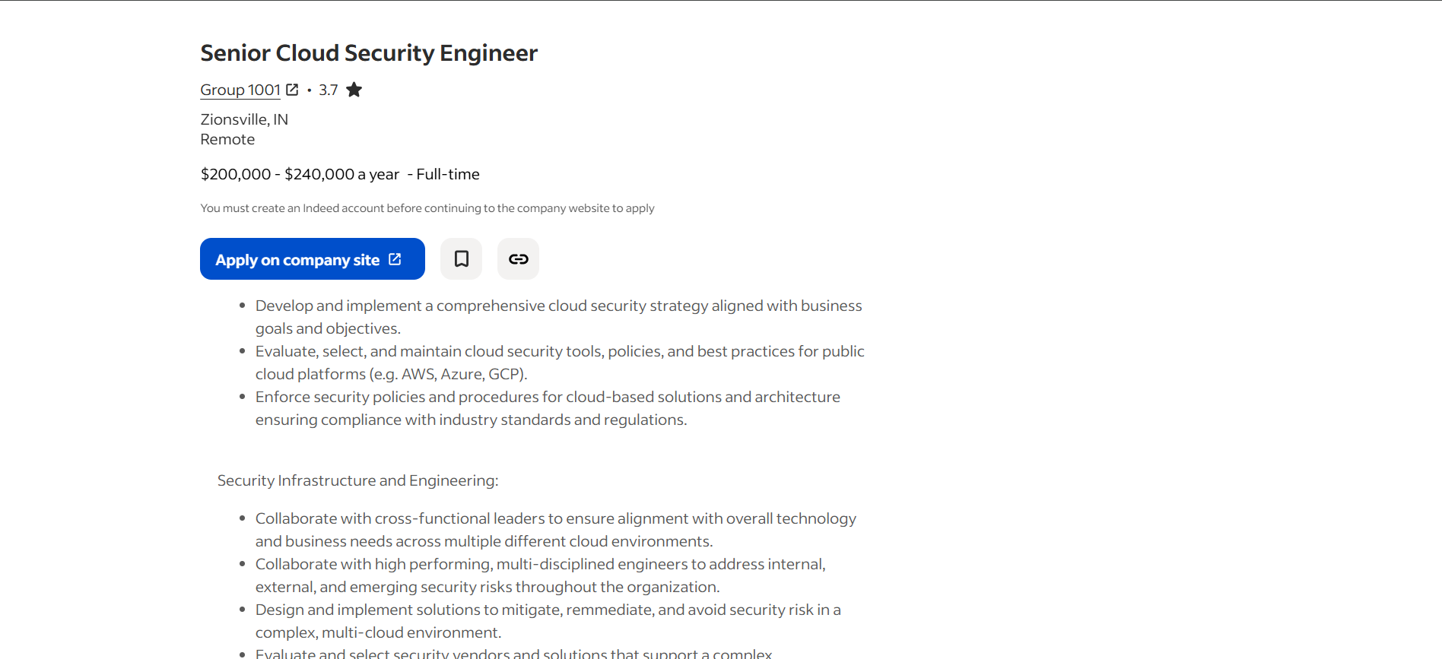
Figure 12 Long Terms Goal Job 1

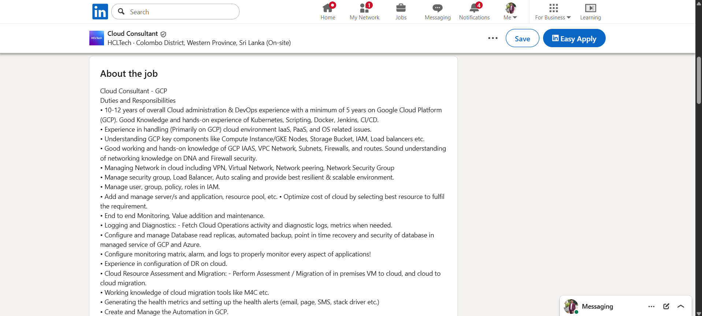
Skill - Cloud Technologies
Figure 13 Long Terms Goal Job 2

